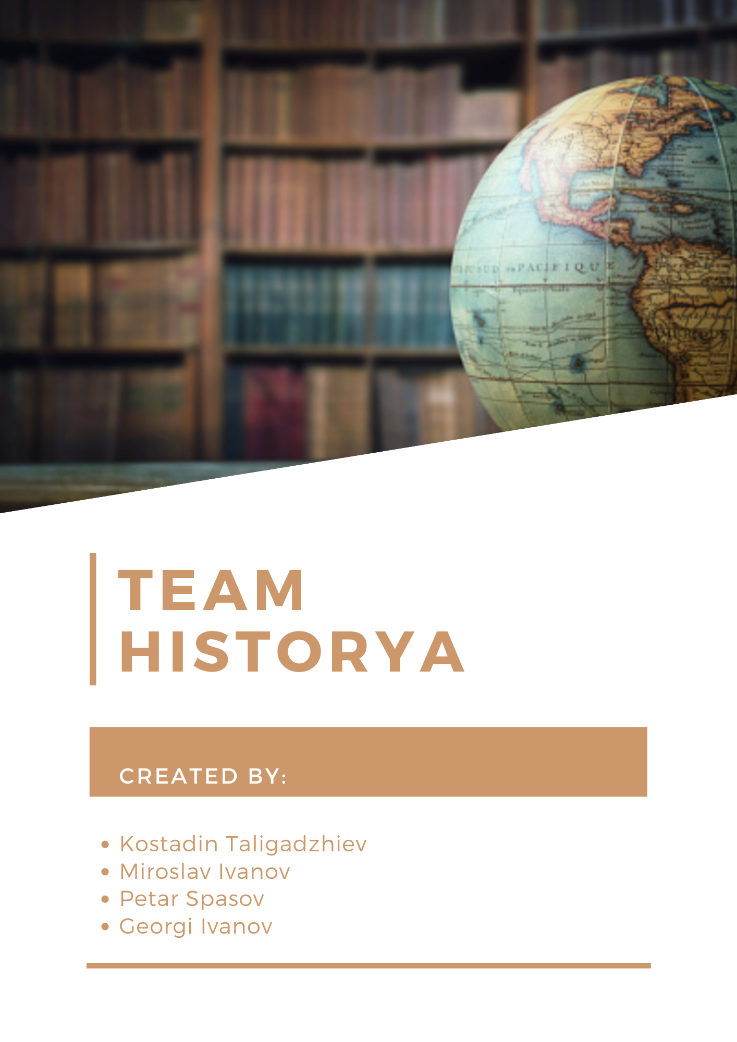Table of contents

Roles in the team 3

Introduction 3

Method and Manner of implementation 4

Plan testing 4

All tasks to perform 4

### Roles in the team

|  |  |
| --- | --- |
| № | Roles in the team |
|  | Miroslav Tenev Ivanov – Scrum Trainer |
|  | Kostadin Nikolaev Taligadzhiev – Back-End Developer |
|  | Georgi Valentinov Ivanov – Front-End Developer |
|  | Petar Zhivkov Spasov – Q&A Engineer |

### Introduction

|  |  |
| --- | --- |
| № | Introduction |
|  | What is the product?  Our product is an application that can be used for education and practice on the dates of historical events. |
|  | Where is it available?  The application is available in our [GitHub repository](https://github.com/KNTaligadzhiev19/historyProject-2022). |
|  | Communication?  To communicate we used Microsoft Teams. |
|  | What technologies are used?  The technologies we used for our project are Microsoft Teams for communication, Git and GitHub for code storage and teamwork on the code, Visual Studio for the code editor, Microsoft PowerPoint for preparing a presentation, Microsoft Word for preparing documentation. |

### Method and Manner of implementation

|  |  |
| --- | --- |
| № | Methods and manner of Implementation |
| 1 | Productive work  We worked regularly on our project with one simple goal: to make an interesting educational application. |
| 2 | Distribution of tasks  The tasks were distributed once the idea was created. Everyone began their work and we checked it often. |

## Plan testing

### All tasks to perform

|  |  |
| --- | --- |
| № | Completed tasks |
| 1 | Systems The system look and design are made by Front End, hashing and textboxes are made by Back End |
| 4 | SFML  All SFML images, representation, placement was job to our Front End |